**Experiment -9**

**Student Name: Aditi R Sinha UID: 22BCS15130**

**Branch: BE-CSE Section/Group: KRG 2B**

**Semester:6th Date of Performance:17/03/2025**

**Subject Name: Project-Based Learning Subject Code: 22CSH-359 in Java with Lab**

**9.1.1 Aim:** To demonstrate dependency injection using Spring Framework with Java-based configuration.

**9.1.2 Objective:**

Define Course and Student classes.

Use Configuration and Bean annotations to inject dependencies. Load Spring context and print student details.

**9.1.3 Code:**

public class Course { private String courseName; private

String duration;

public Course(String courseName, String duration) { this.courseName = courseName;

this.duration = duration;

}

public String getCourseName() { return courseName; } public String getDuration() { return duration; }

@Override

public String toString() { return "Course: " + courseName + ", Duration: " + duration;

}

}

public class Student { private String name; private Course course;

public Student(String name, Course course) { this.name = name; this.course = course;

}

public void showDetails() { System.out.println("Student: " + name); System.out.println(course);

} }

import org.springframework.context.annotation.*;

@Configuration public class AppConfig { @Bean public Course course() { return new Course("Java", "3 months");

}

@Bean

public Student student() { return new Student("Aman", course()); } }

import org.springframework.context.ApplicationContext;

import org.springframework.context.annotation.AnnotationConfigApplicationContext;

public class MainApp { public static void main(String[] args) { ApplicationContext context = new

AnnotationConfigApplicationContext(AppConfig.class); Student student = context.getBean(Student.class); student.showDetails();

}

}

**Output:**

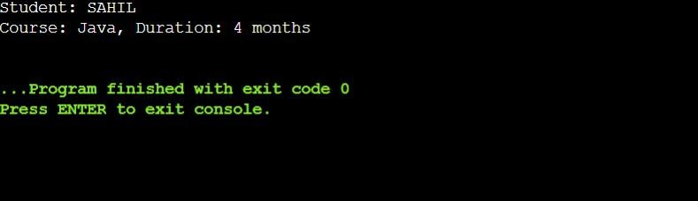

# Experiment -9.2

**Aim:** To perform CRUD operations on a Student entity using HibernateORM with MySQL.

**Objective**: Define Course and Student classes.

Use Configuration and Bean annotations to inject dependencies.

Load Spring context and print student details.

**Code:**

<hibernate-configuration>

<session-factory>

<property

name="hibernate.connection.driver_class">com.mysql.cj.jdbc.Driver</property>

<property

name="hibernate.connection.url">jdbc:mysql://localhost:3306/testdb</property>

<property name="hibernate.connection.username">root</property>

<property name="hibernate.connection.password">password</property>

<property

name="hibernate.dialect">org.hibernate.dialect.MySQL8Dialect</property>

<property name="hibernate.hbm2ddl.auto">update</property>

<mapping class="Student"/>

</session-factory>

</hibernate-configuration> import javax.persistence.*;

Entity

public class Student {

Id

GeneratedValue(strategy = GenerationType.IDENTITY) private int id; private String name; private int age;

public Student() {}

public Student(String name, int age) { this.name = name; this.age = age;

}

}

import org.hibernate.SessionFactory; import org.hibernate.cfg.Configuration;

public class HibernateUtil { private static final SessionFactory sessionFactory;

static { sessionFactory = new Configuration().configure().buildSessionFactory();

}

public static SessionFactory getSessionFactory() { return sessionFactory;

}

} import org.hibernate.*;

public class MainCRUD { public static void main(String[] args) {

Session session = HibernateUtil.getSessionFactory().openSession();

Transaction tx = session.beginTransaction(); Student s1 = new Student("Aman", 22);

session.save(s1);

tx.commit();

Student student = session.get(Student.class, 1);

System.out.println(student);

tx = session.beginTransaction(); student.setAge(23); session.update(student); tx.commit();

tx = session.beginTransaction(); session.delete(student); tx.commit();

session.close();

}

}

**Output:**

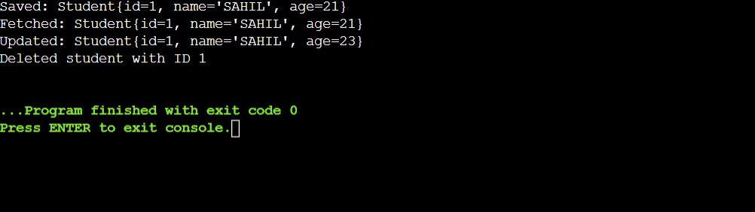

# Experiment -9.3

**Aim:** To implement a banking system using Spring and Hibernate that ensures transaction consistency during fund transfers.

**Objective:**

Integrate Spring + Hibernate.

Handle transactions atomically (rollback on failure). Demonstrate success and failure cases.

**Code:**

import javax.persistence.*;

Entity

public class Account { @Id private int accountId; private String holderName; private double balance;

}

import javax.persistence.*; import java.util.Date;

@Entity

public class BankTransaction { @Id

@GeneratedValue(strategy = GenerationType.IDENTITY) private int txnId; private int fromAcc; private int toAcc; private double amount;

private Date txnDate = new Date();

}

import org.hibernate.*;

import org.springframework.transaction.annotation.Transactional;

public class BankService { private SessionFactory sessionFactory;

public BankService(SessionFactory sessionFactory) { this.sessionFactory = sessionFactory; }

@Transactional

public void transferMoney(int fromId, int toId, double amount) { Session session = sessionFactory.getCurrentSession();

Account from = session.get(Account.class, fromId); Account to = session.get(Account.class, toId);

if (from.getBalance() < amount) { throw new RuntimeException("Insufficient Balance"); }

from.setBalance(from.getBalance() - amount); to.setBalance(to.getBalance() + amount);

session.update(from); session.update(to);

BankTransaction txn = new BankTransaction(fromId, toId, amount); session.save(txn);

}

}

@Configuration

@EnableTransactionManagement public class AppConfig {

@Bean

public DataSource dataSource() {

DriverManagerDataSource ds = new DriverManagerDataSource(); ds.setDriverClassName("com.mysql.cj.jdbc.Driver");

ds.setUrl("jdbc:mysql://localhost:3306/testdb"); ds.setUsername("root"); ds.setPassword("password");

return ds;

}

@Bean

public LocalSessionFactoryBean sessionFactory() {

LocalSessionFactoryBean lsf = new LocalSessionFactoryBean(); lsf.setDataSource(dataSource()); lsf.setPackagesToScan("your.package"); Properties props = new Properties();

props.put("hibernate.dialect", "org.hibernate.dialect.MySQL8Dialect"); props.put("hibernate.hbm2ddl.auto", "update"); lsf.setHibernateProperties(props); return lsf;

}

@Bean

public HibernateTransactionManager transactionManager(SessionFactory sf) { return new HibernateTransactionManager(sf); }

@Bean

public BankService bankService(SessionFactory sf) { return new BankService(sf);

}

}

public class MainApp { public static void main(String[] args) {

AnnotationConfigApplicationContext ctx = new

AnnotationConfigApplicationContext(AppConfig.class); BankService service = ctx.getBean(BankService.class);

try { service.transferMoney(101, 102, 500); System.out.println("Transaction Successful!");

} catch (Exception e) {

System.out.println("Transaction Failed: " + e.getMessage()); }

ctx.close();

}

}

**OUTPUT:**

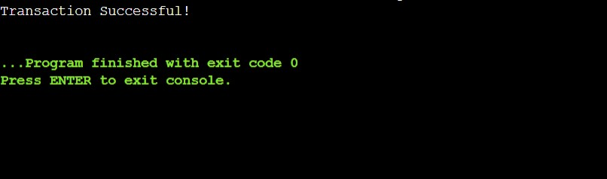

**Learning Outcome:**

* Learned how to define and manage **Spring beans** using @Configuration, @Bean, and dependency injection. I understood the working of a simple Java application wired using **Spring’s ApplicationContext**, which improves modularity and decoupling.

* Explored **Hibernate ORM** to perform CRUD operations on a database using entity classes mapped via annotations. I learned how to configure hibernate.cfg.xml, establish a connection with MySQL, and use Hibernate’s SessionFactory, Session, and Transaction objects to persist and manipulate data.

* Learned to combine both Spring and Hibernate to simulate a **real-world banking transaction system**. I learned how to handle transactions using @Transactional, manage dependencies using Spring's @Configuration and @Bean annotations, and implement business logic for transferring money securely between accounts with rollback support in case of errors.